Final Details: Hodgson Brothers Mountain Relay Saturday 5th October 2024

What do I need to do?
- If you want to change the category of a team this must be done by midnight Tuesday 1st October - but please remember that you can’t enter more than one team in any single category. For category changes e-mail us at hodgsonrelay@gmail.com
- Make sure you have added all your leg runners onto Si Entries - you have until midnight Wednesday 2nd October to make any changes.
- Read the Race Rules on https://hbmr.org.uk/on-the-day/ and make sure your Team members are briefed accordingly. You should pay particular attention to the Safety Equipment that must be carried. Kit checks will be done for each leg and rigorously enforced. Please note the Race Rule relating to the use of GPS as a navigation aid – GPS is not allowed!
- There is a cut-off at Hart Crag (Leg 4) of 14.10pm (or +1 hour on the Leg 4 mass start time if it is different to 13.10pm). This is for the safety of both runners and marshals.
- Visit the Registration Page at https://hbmr.org.uk/registration/ and make sure your Team Captain has printed out and completed the Registration Form, we will not accept incomplete Registration Forms - individual details are required for each and every runner in the event of an emergency. The form must be handed in at the Race Registration Tent between 07.45 and 08.45am (at the latest) on Sat 5th October. This website page will also include the Start List from Thursday 3rd October on which you will find your relevant Team Number. If there are any questions relating to this, please contact Sara Hodgson (details at the bottom of the mail)
- Organise your Maps. You can either use your own maps or buy copies of the special Hodgson Mountain Relay map which is a 1:40,000 Harvey’s map and available at a price of £6. These are waterproof, fully marked with all the checkpoints and also have a suggested route highlighted. You can buy these in advance from Pete Bland Sports at this link here or they will have some on the day at the event https://www.peteblandsports.co.uk/buy/harvey-hodgson-brothers-relay-race-map_5495.htm?sid=4423680
- Please bring your own Safety Pins; we don’t need to hand out another 2240 when everybody already has some anyway.

Changes to Legs 3 and 4
We have switched the final part of the Leg 3 descent and Leg 4 start around to make it easier for finishing Leg 3 runners to overtake; this now means one more checkpoint on Leg 3 (the footbridge on the way down to Hartsop Hall) and one less on Leg 4.
Here is the link to all leg checkpoints and the map of the changes, it’s your responsibility to communicate these changes to your team https://hbmr.org.uk/leg-routes/

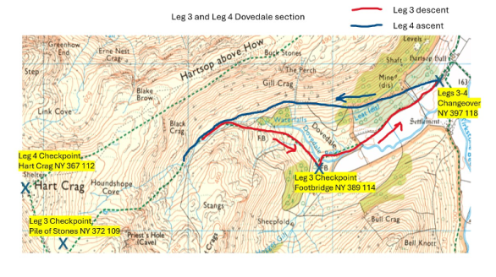
Last minute information
Any important last-minute info will be sent out via a SPORTident e-mail direct to you and also posted on:
• The Event website page http://hbmr.org.uk/on-the-day/
• The Event Facebook page https://www.facebook.com/hodgsonrelay/
Car Parking
All car parking arrangements are weather dependent, details will be sent out early next week but car sharing will be required amongst teams.
NB – Overnight camping is not allowed on the race field or carpark, either in camper vans or tents.

Patterdale School Refreshments
The race is an important fixture in the year for Patterdale School and plays a big role in their annual fund-raising efforts. The school is located on the road where you turn off to Side Farm on Leg 1. As usual staff, ex-pupils and friends will be running a superb refreshment facility before, during and after the race to refresh your soul after your running efforts. Please support them by consuming their food & beverages!
The school is trying to eliminate the need for disposable cups; please bring a re-usable cup for your hot drinks and the team will fill them with steaming hot tea or coffee. Beer will also be on-sale 😊. Please note cash only for refreshments.

Are you struggling to get a full team together?
One final request; if you are struggling to get a team together, please consider withdrawing your team and letting another Club run in your place; we have a list of Clubs wanting to run. Contact Sara at the soonest opportunity if this is the case.

Timings
• Date – Saturday 5th October 2024
• Registration 8.00 – 9.00am
• Start 9:30am

If you have any other questions, please contact:
For Entries:
Sara Hodgson Tel 07837 700431 / E-mail hodgsonrelay@gmail.com
General Enquiries:
Chris Hodgson Tel 07811 199125 / E-mail info@chalet365.com

Good luck and we’ll see you on the morning of Saturday 5th, please remember No Registration Form = No Race!!!!!
Chris, Sara, Jon & Scoffer

